NAT Gateway

NAT – Network Address Translation

Scope of NAT GW is at AZ level.

It is deployed in public subnet.

Private Subnet Route table shown below where ec2 instance resides that uses NAT GW for downloading packages through internet:-

|  |  |
| --- | --- |
| Destination | Target |
| 10.100.0.0/16 | local |
| 0.0.0.0/0 | Nat-xxx |

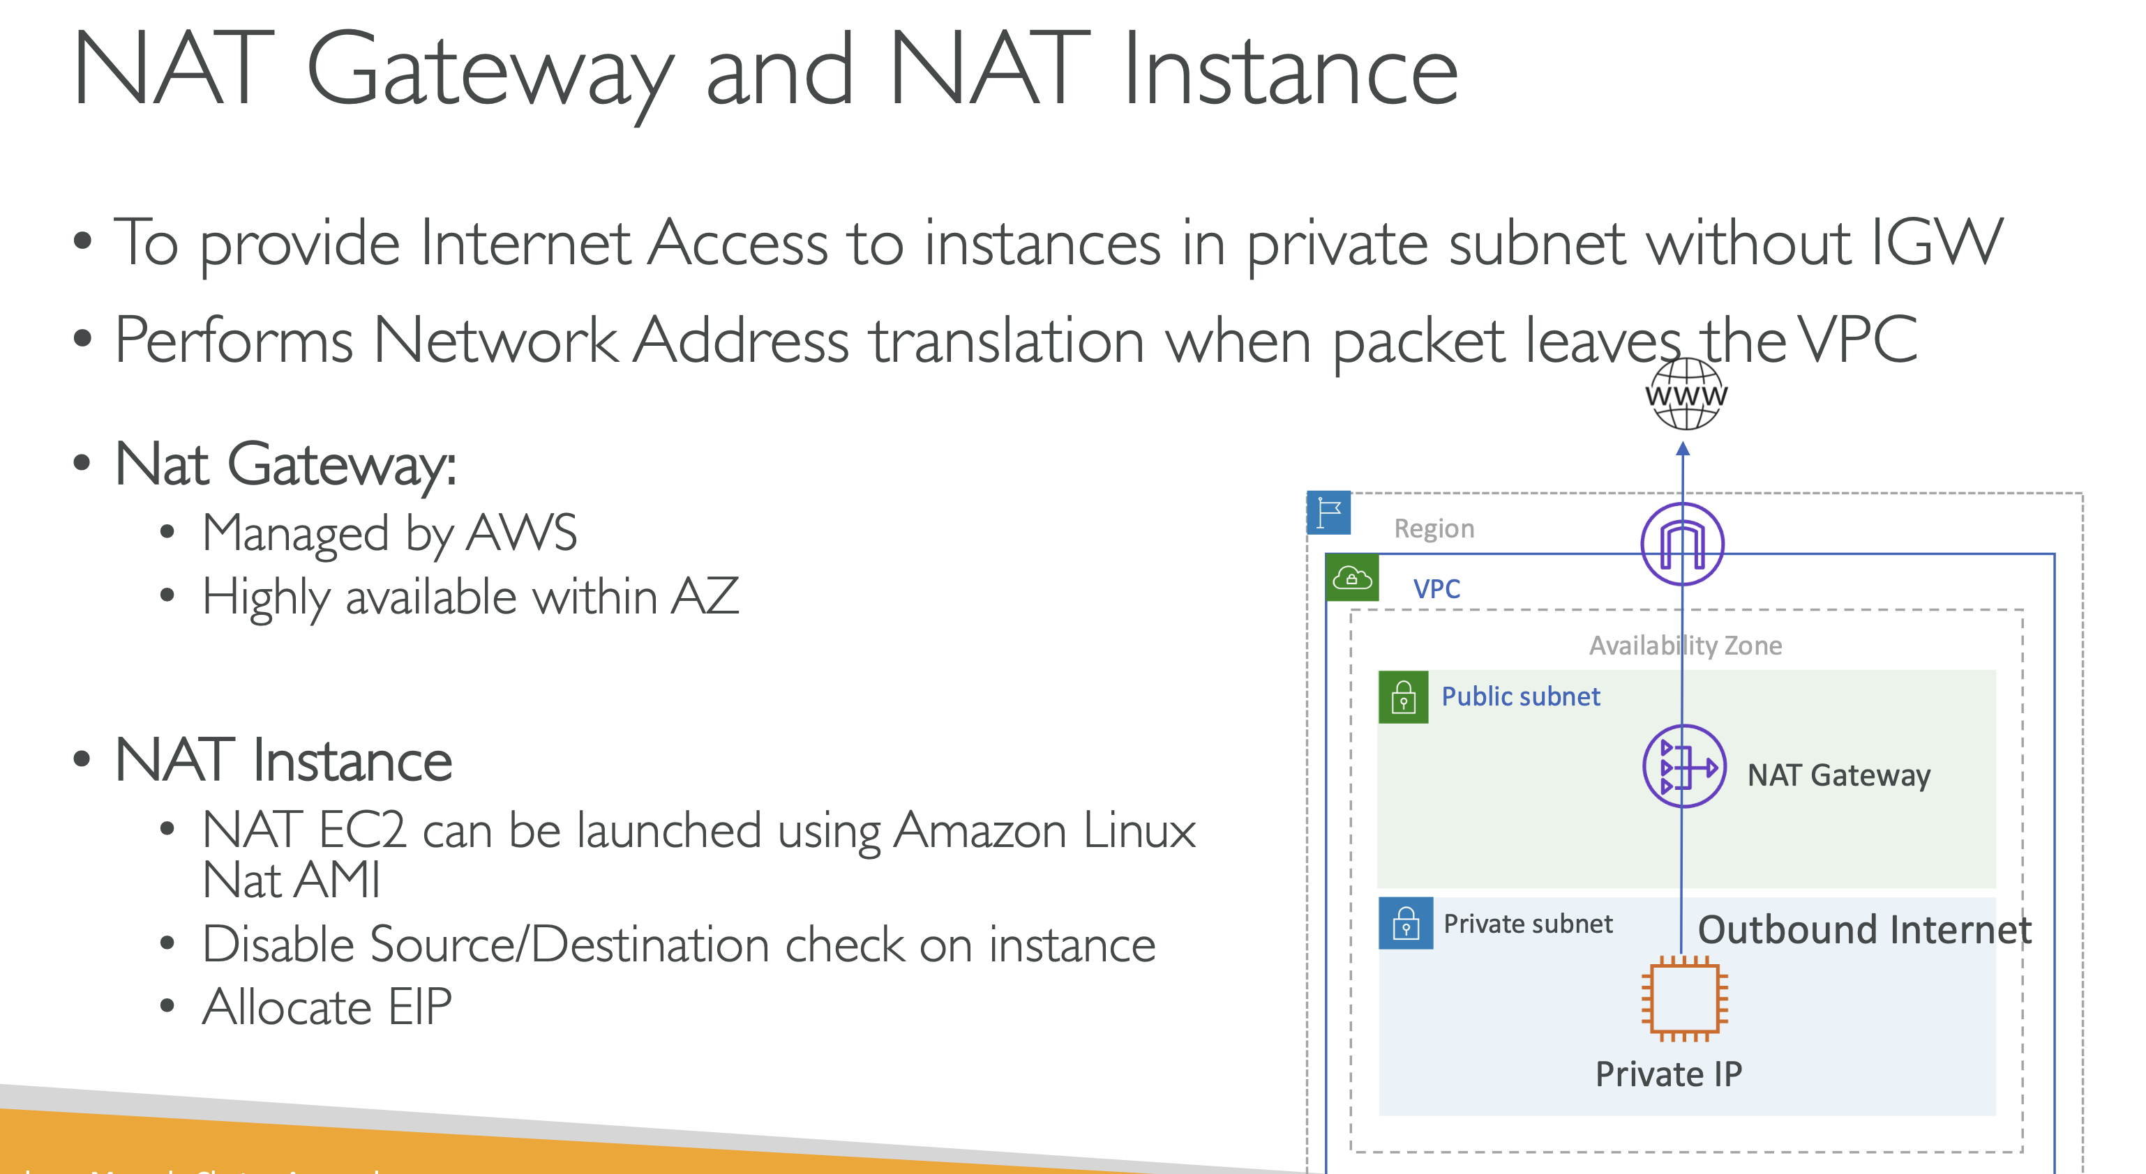

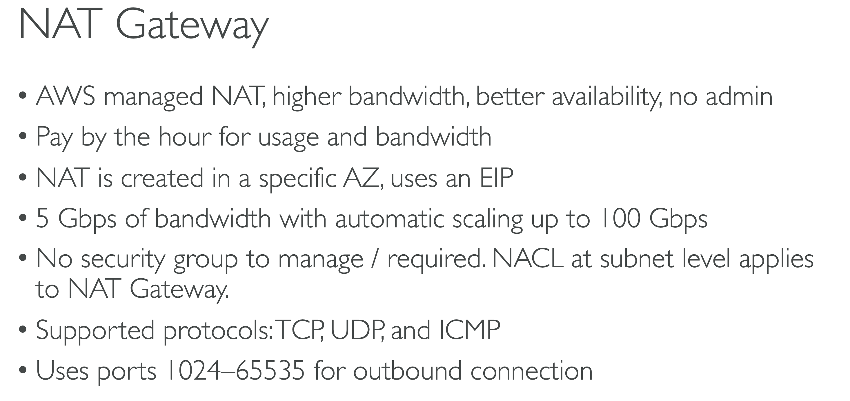

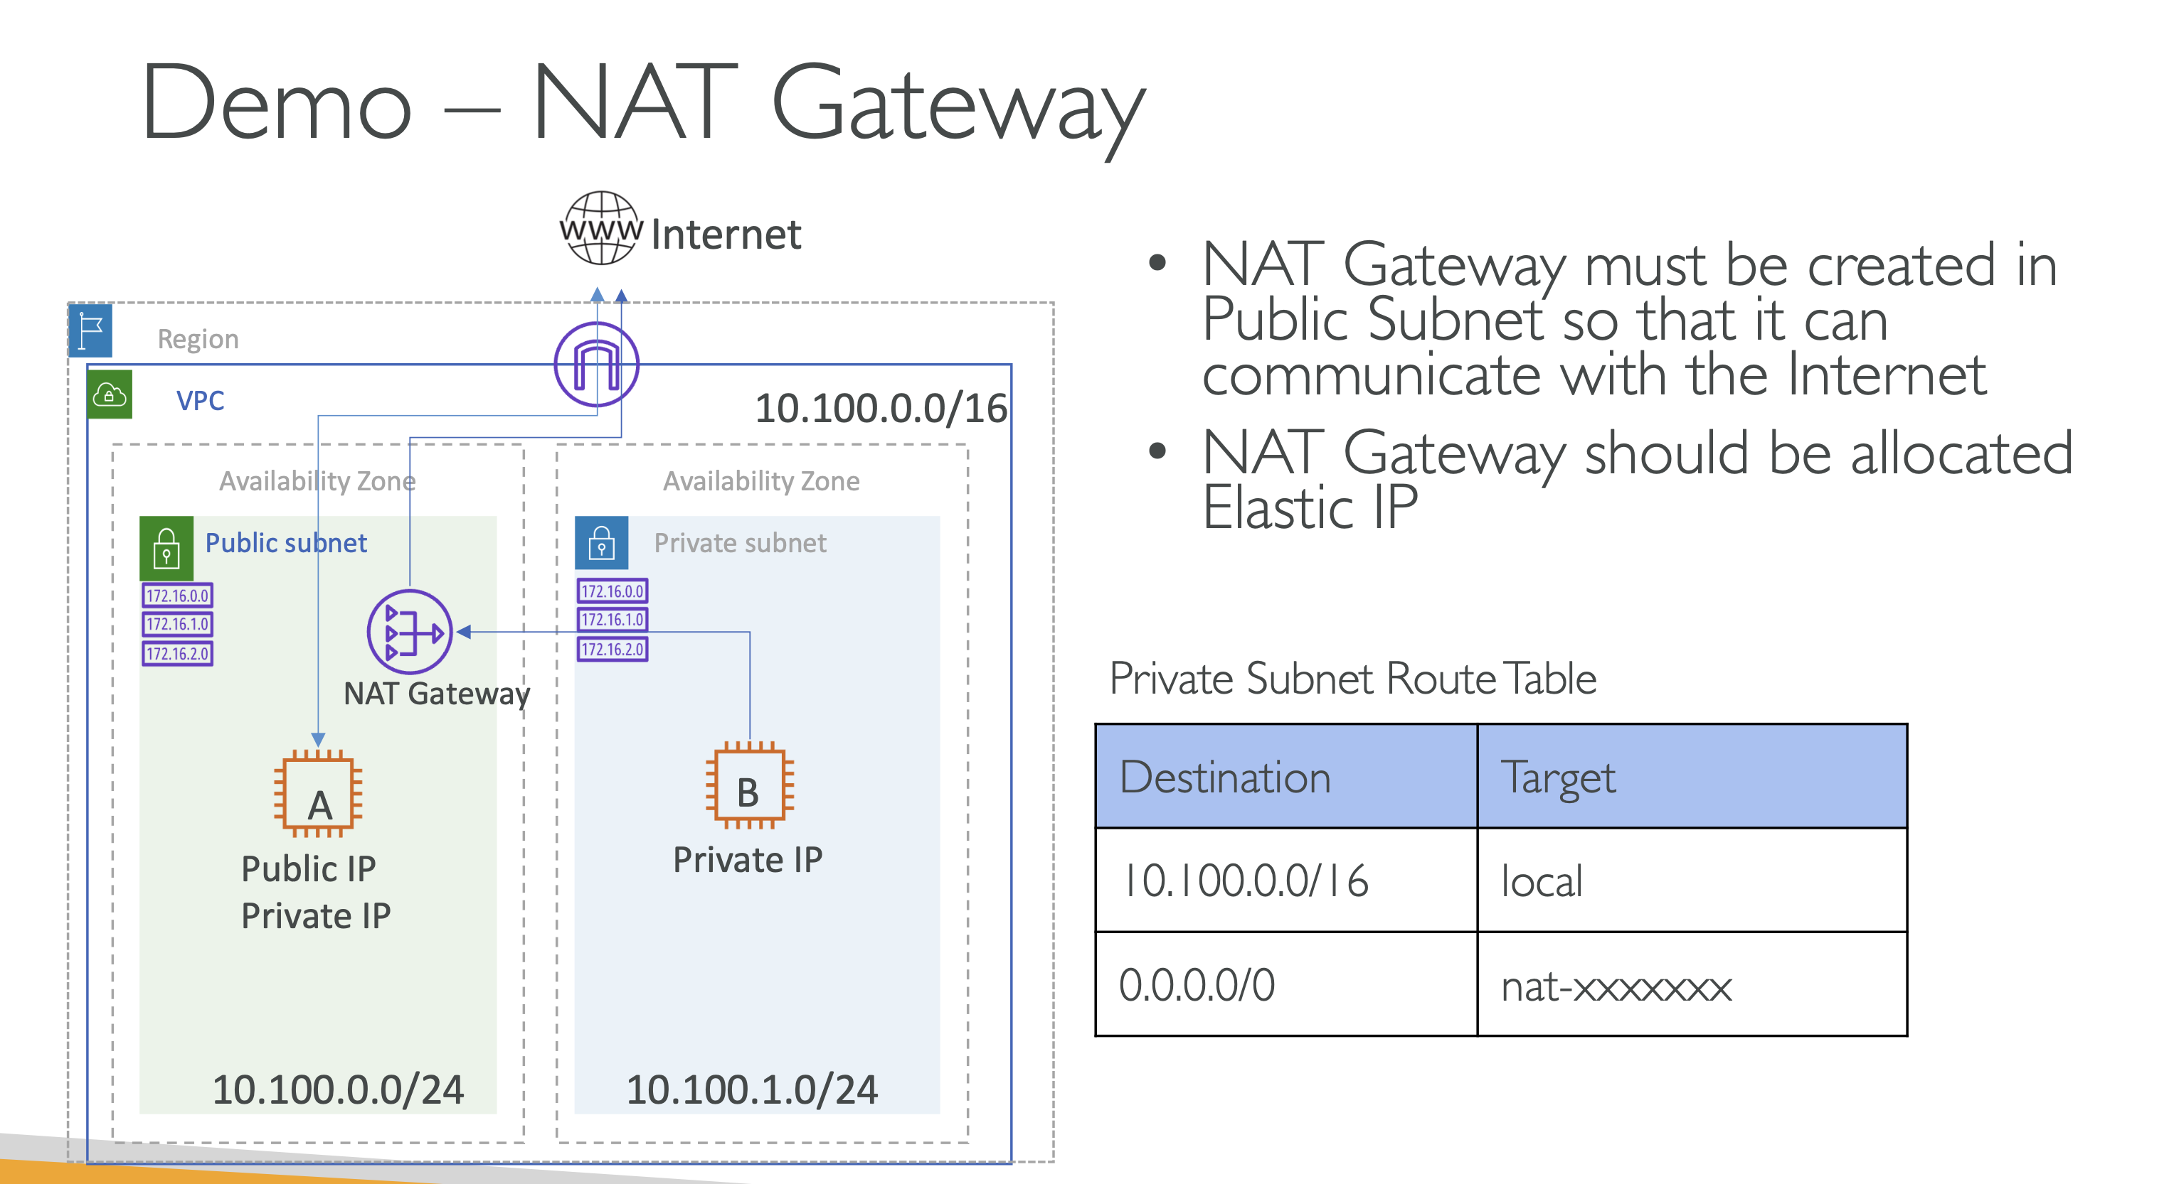

NAT GW with High Availability: The recommended design is to have NAT GW in each of the AZs. However cross AZ design also possible i.e ec2 instances in private subnet in AZ1 can reach out to NAT GW in AZ2.

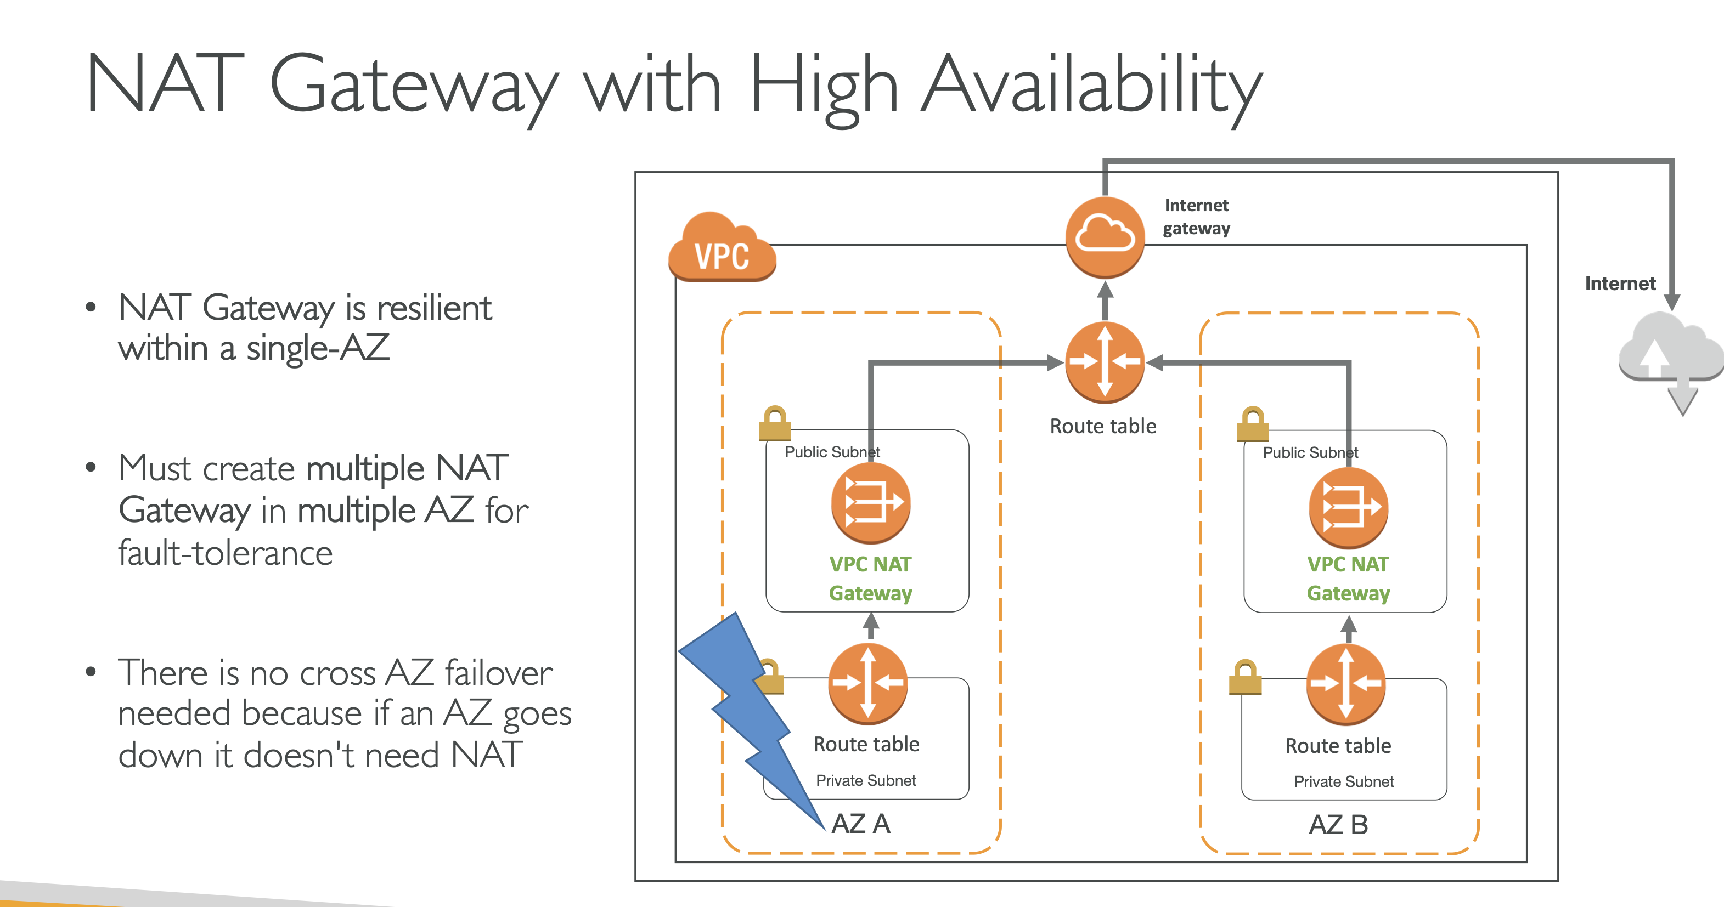

NAT Instance (NAT on ec2) :-

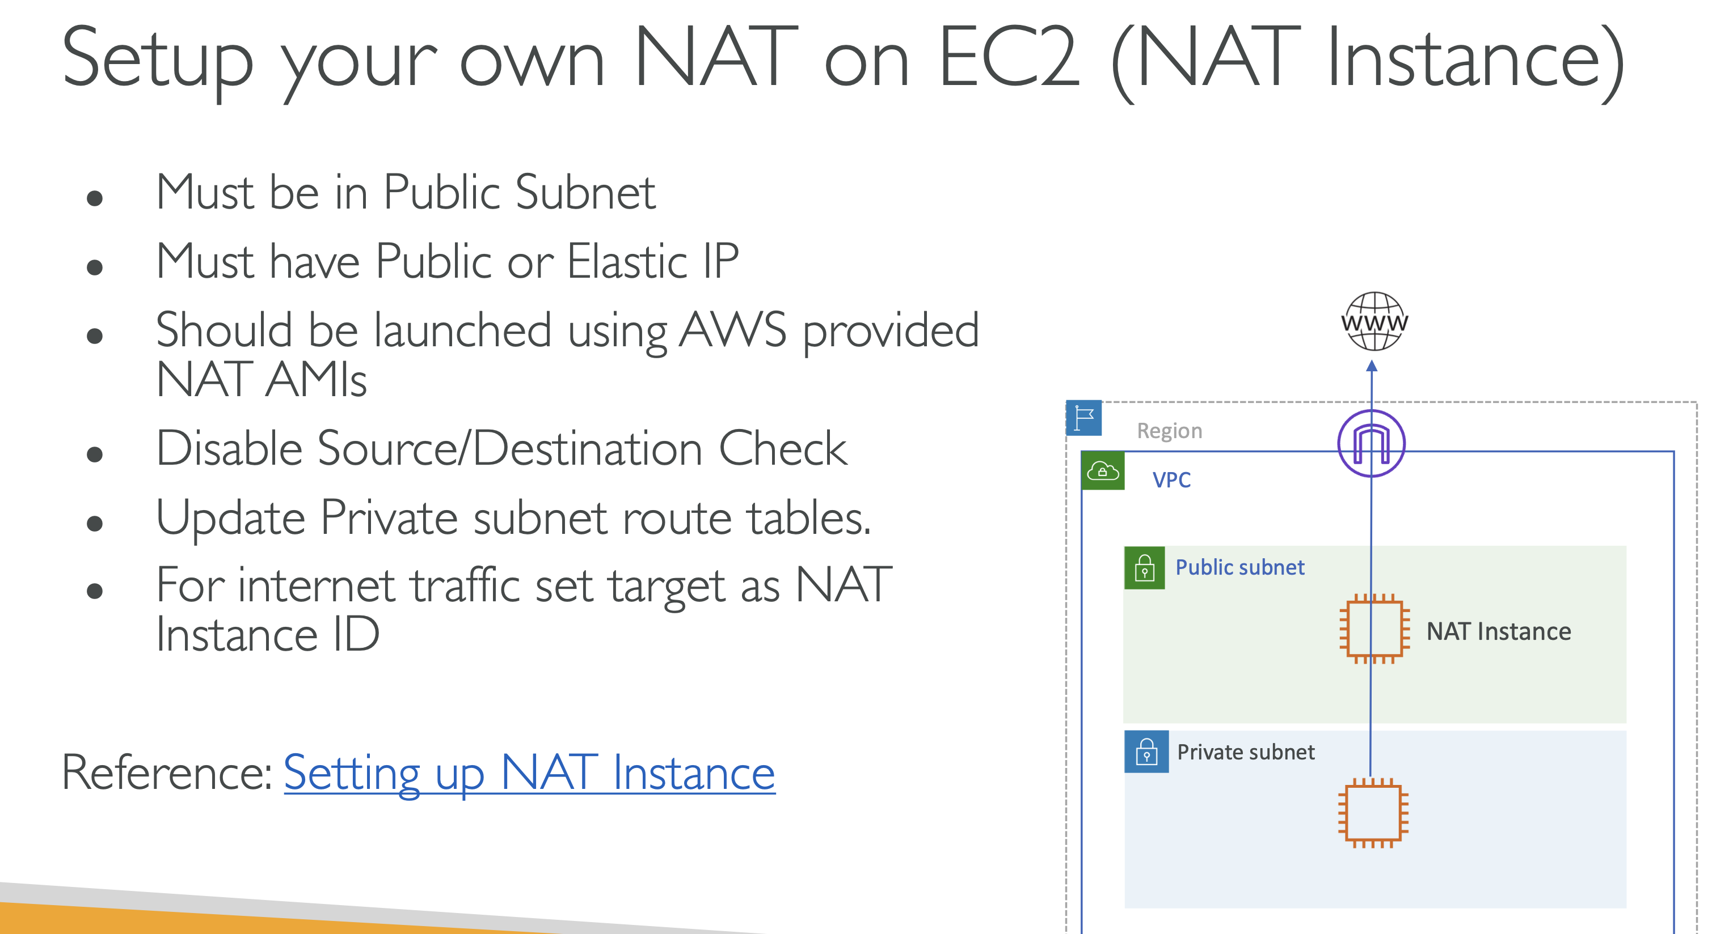

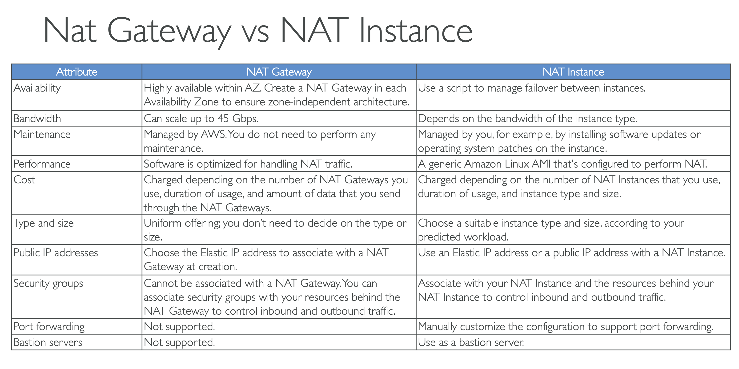

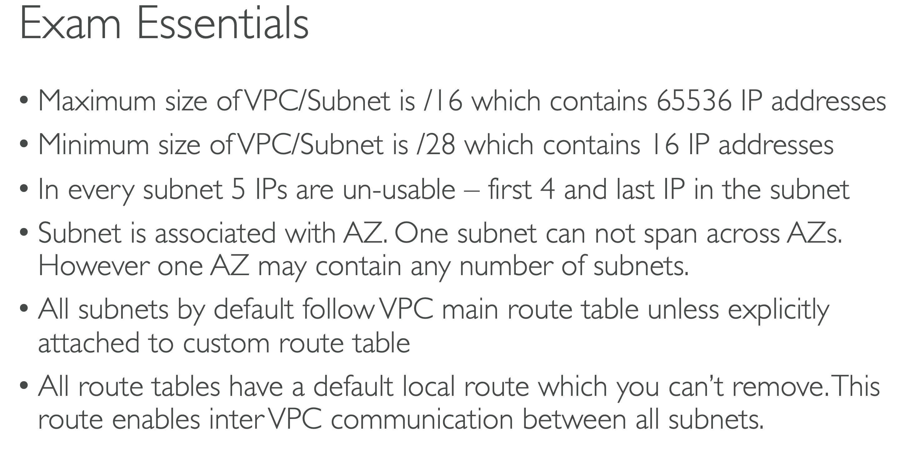

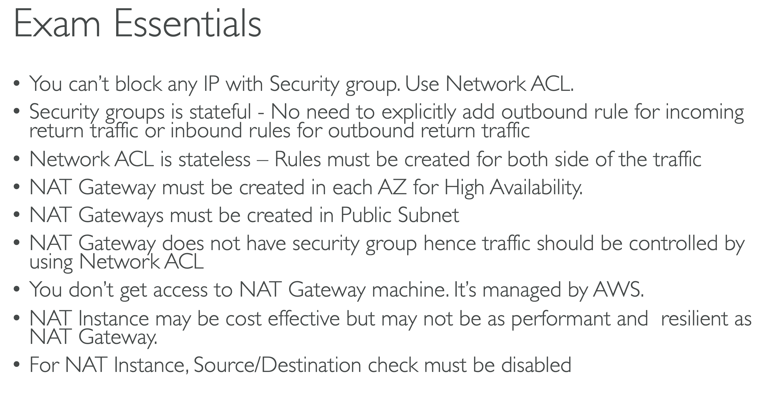

Regional NAT Gateway:-

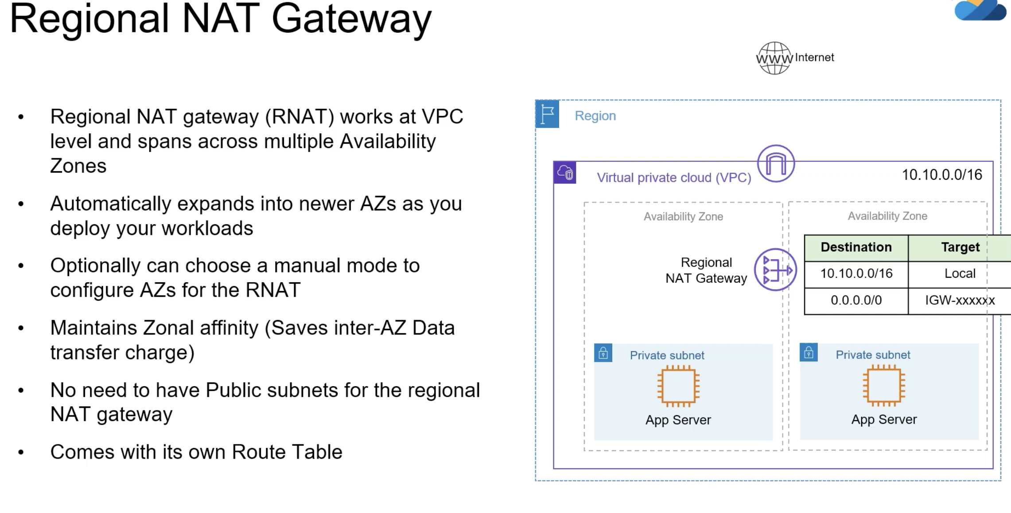

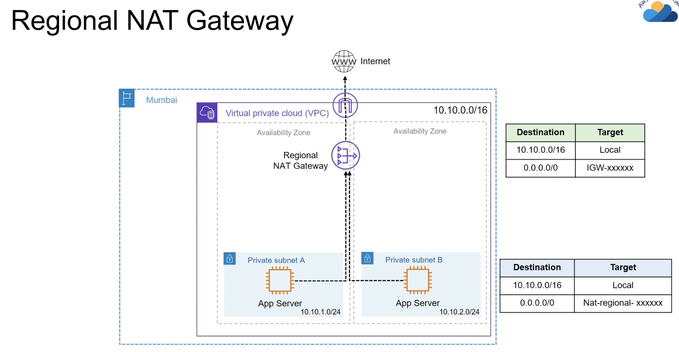

Some important points:-

**Elastic Network Interfaces (ENIs) allow you to create dual-homed EC2 instances in an Amazon VPC.**

A **dual-homed instance** is an EC2 instance that has **more than one network interface**, typically to connect it to:

* Multiple subnets

In Amazon VPC:

* **ENIs allow you to attach multiple network interfaces to a single EC2 instance**
* Each ENI can be:
  + In a different subnet (within the same AZ)

**An EC2 instance can be connected to two subnets by attaching multiple ENIs**,  
but **all those subnets must be in the same Availability Zone**.